LIT_DAY8 - ASSIGNMENT

Name : Pathe Kavya Malathi

Emp.ID;- 46255265.

Batch: sap abap 25.

1. Create a custom Idoc whose fields refers to a custom table. Create a Custom Segment, Idoc type, & Message Type in IDOC.(Tools Used we31,we30).

step 1: Go to WE31.

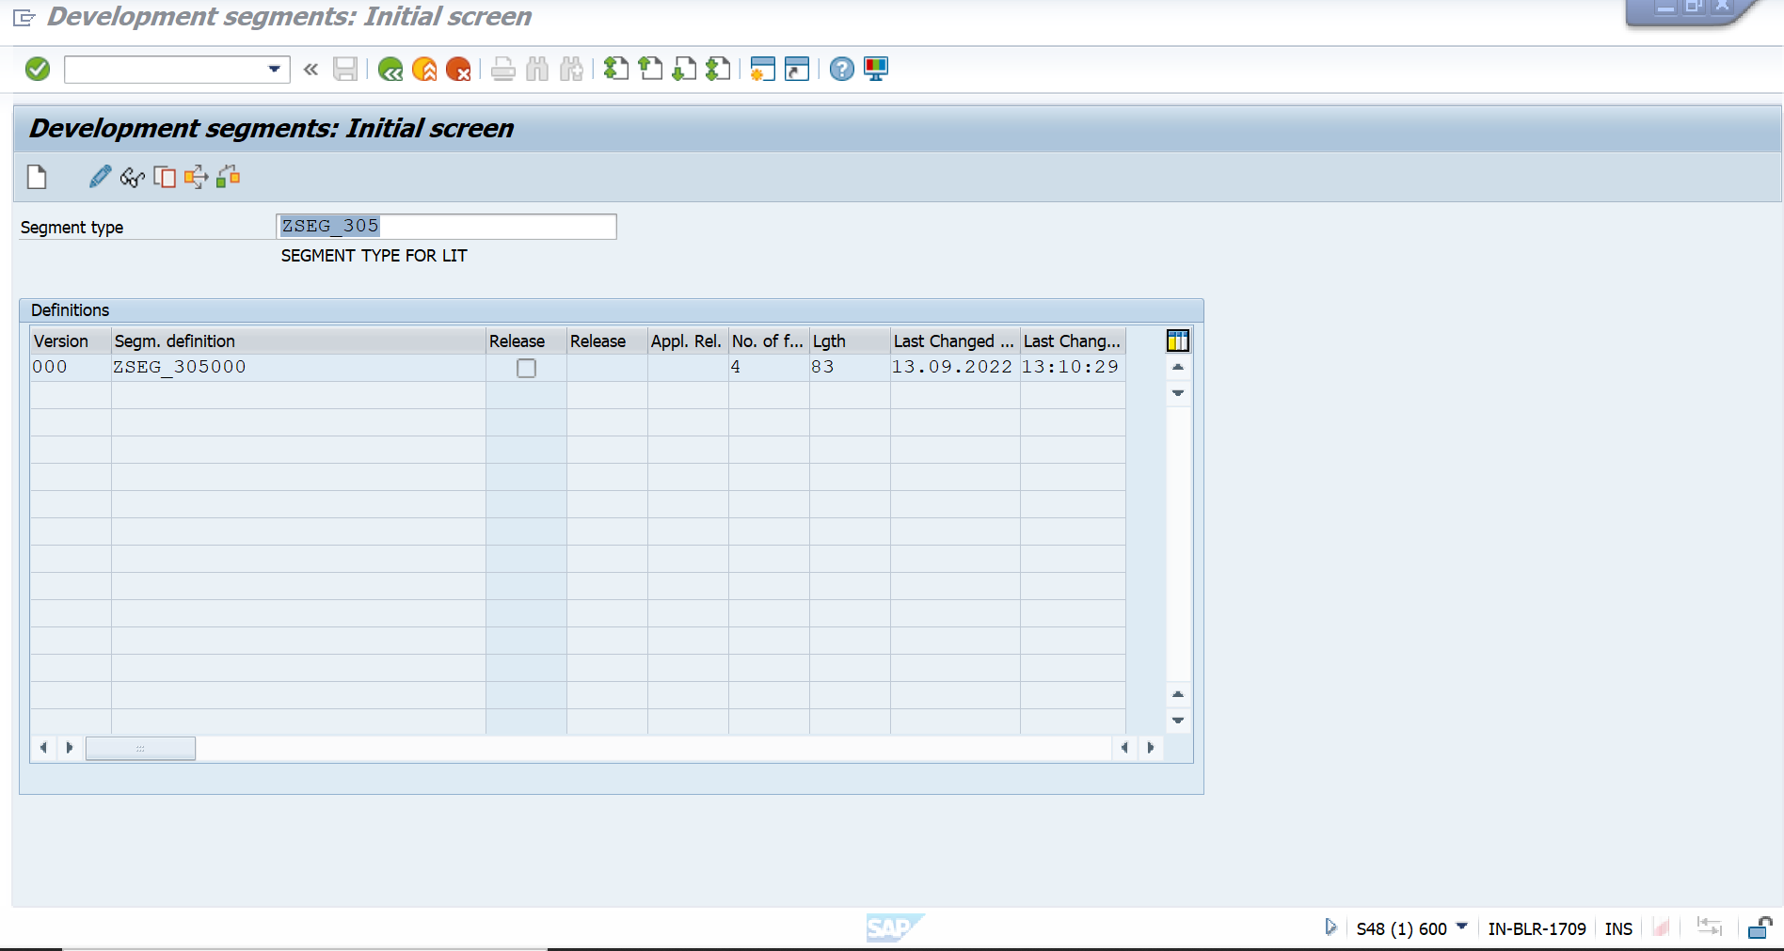

STEP 2 :- WE30

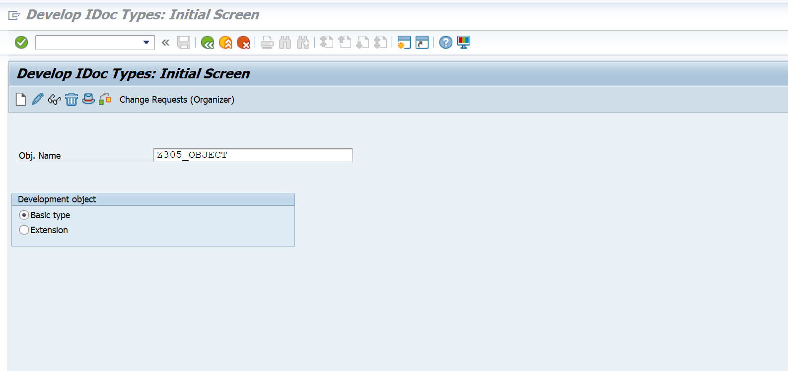

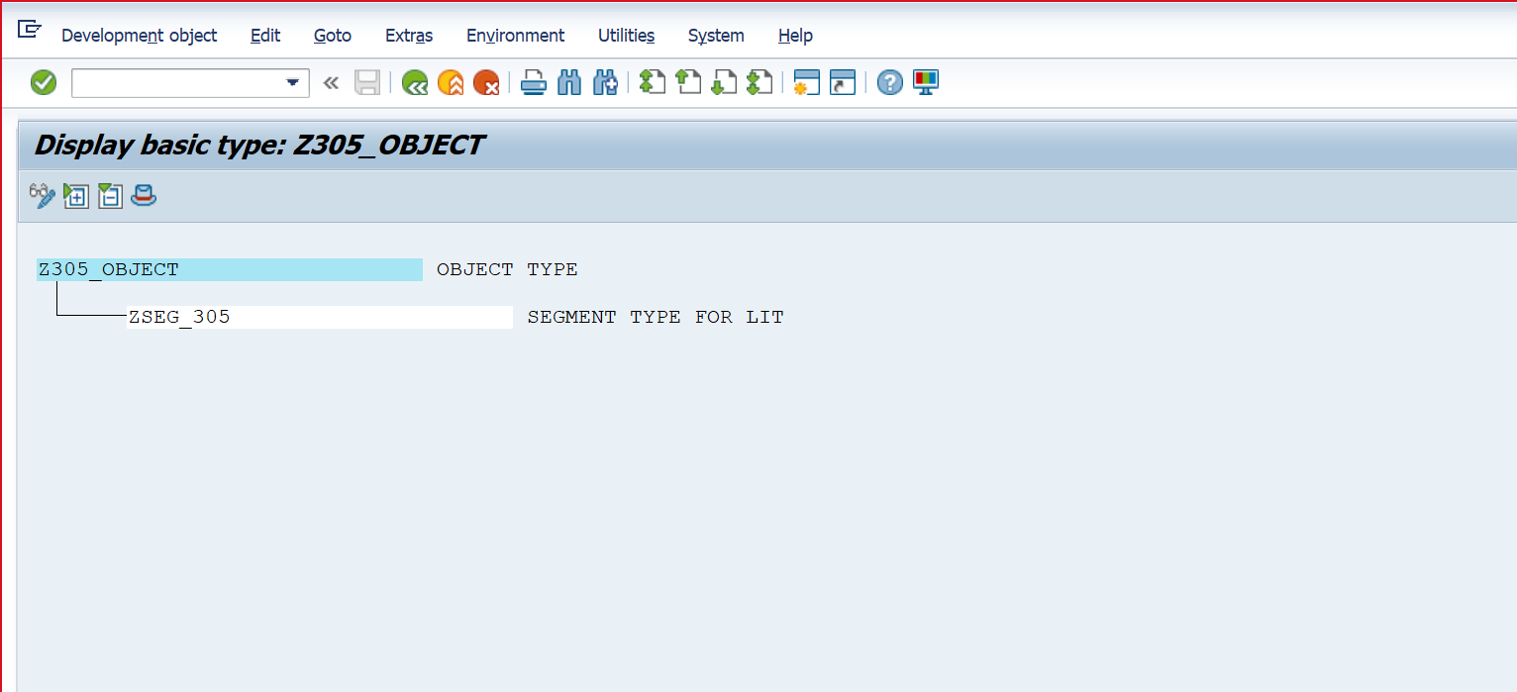

step 3 :- WE81

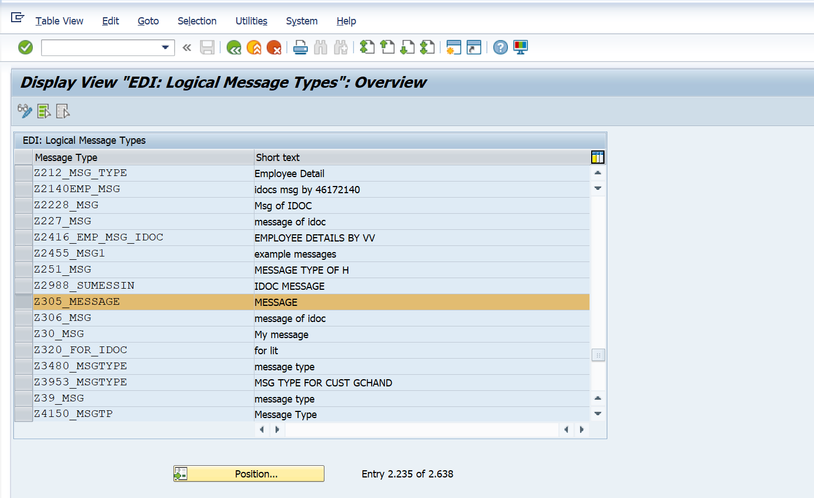STEP 4 ;- WE82

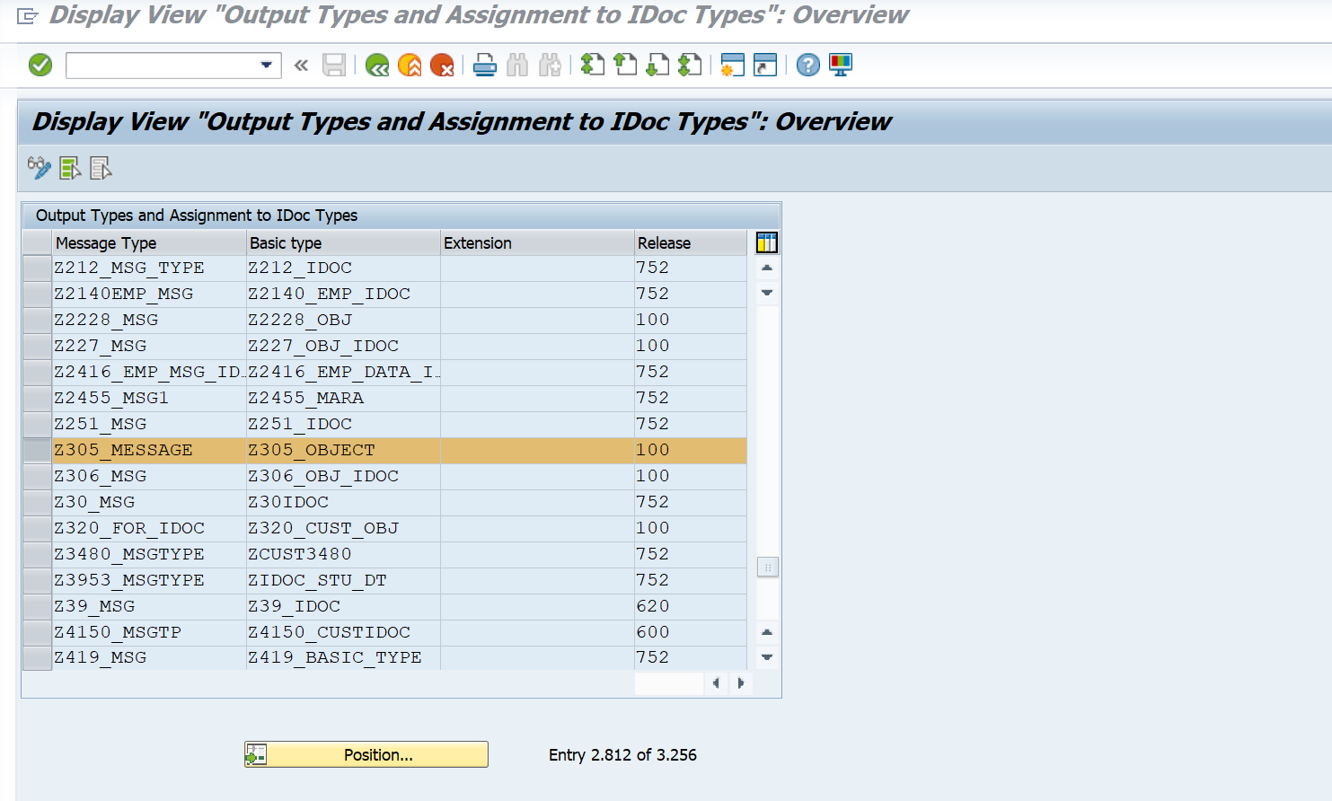

2. Create a inbound function module to update the data in a custom table. Below input output fields needed:

WE31 :- SEGMENT TYPE







WE81 :- MESSAGE TYPE

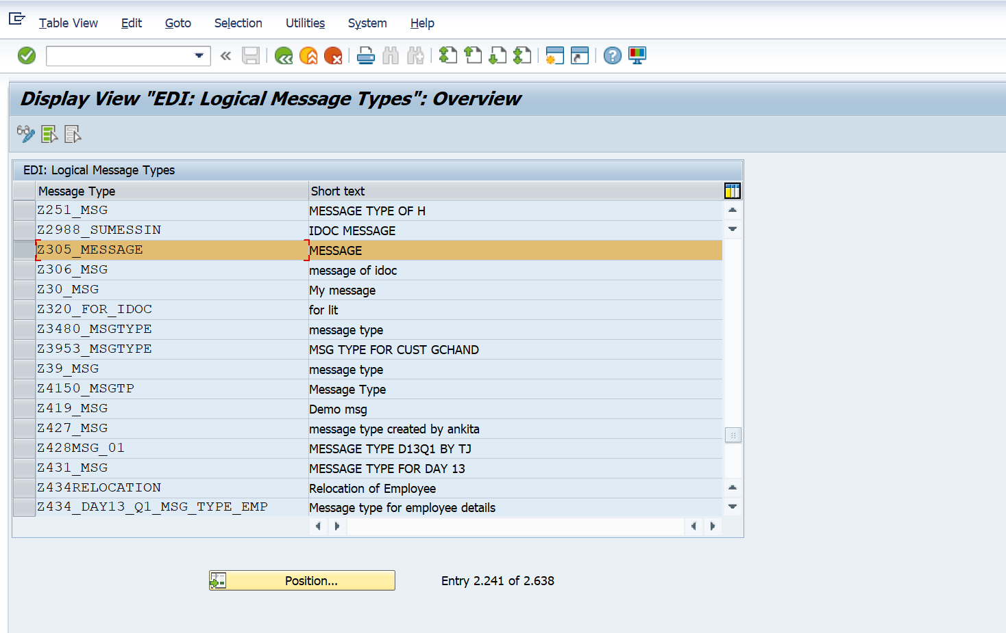

WE82 :- ASSIGN MESSAGE TYPE (RELEASE )

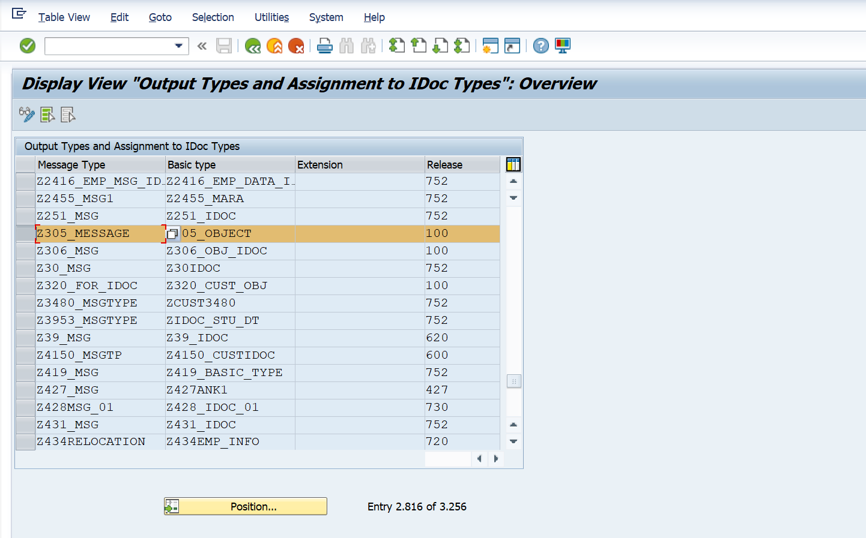

SE80 :- FUNCTION GROUP

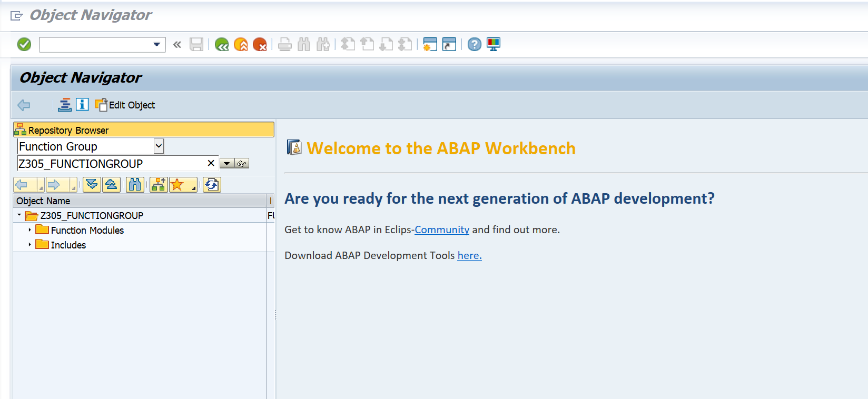

SE37 :- FUNCTION MODULE

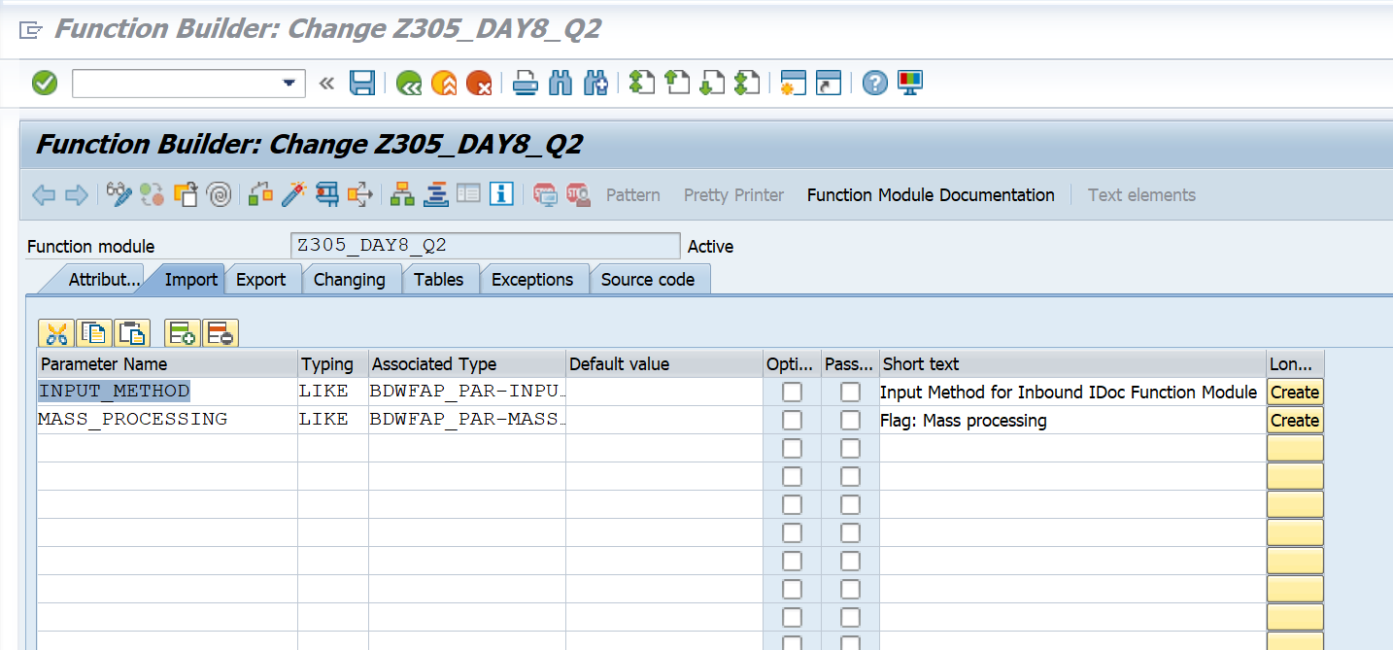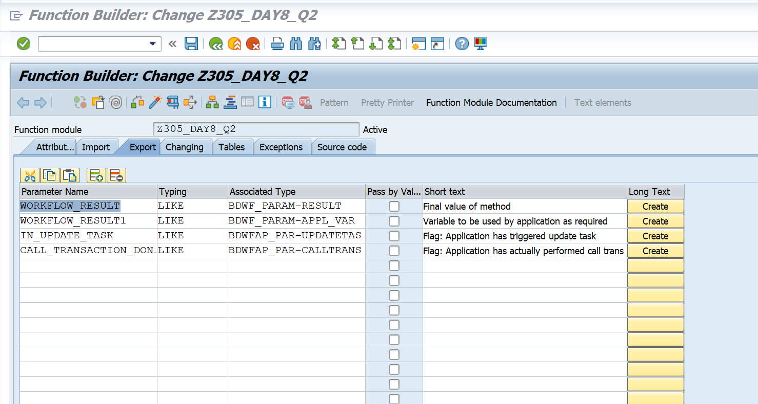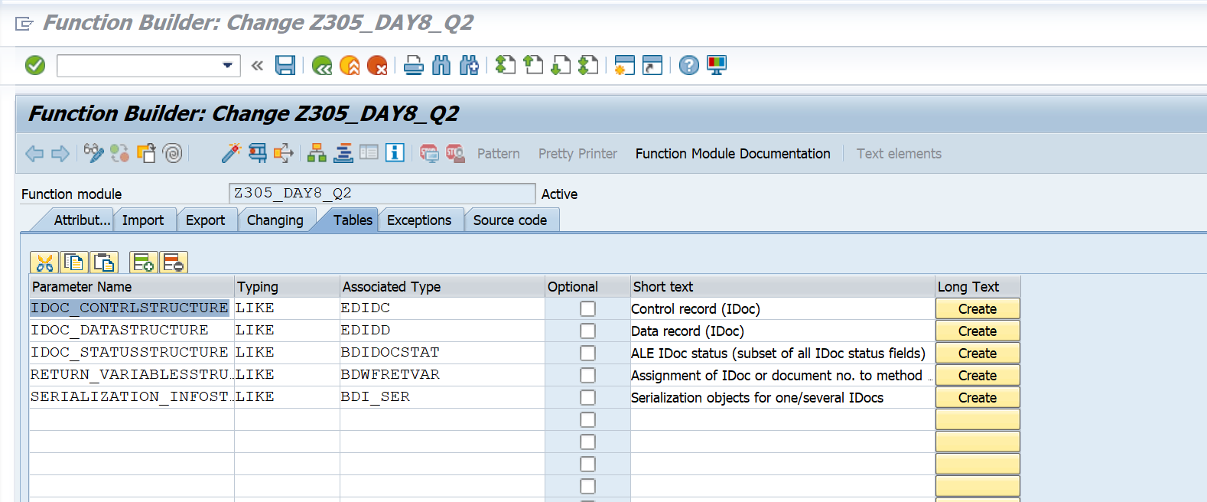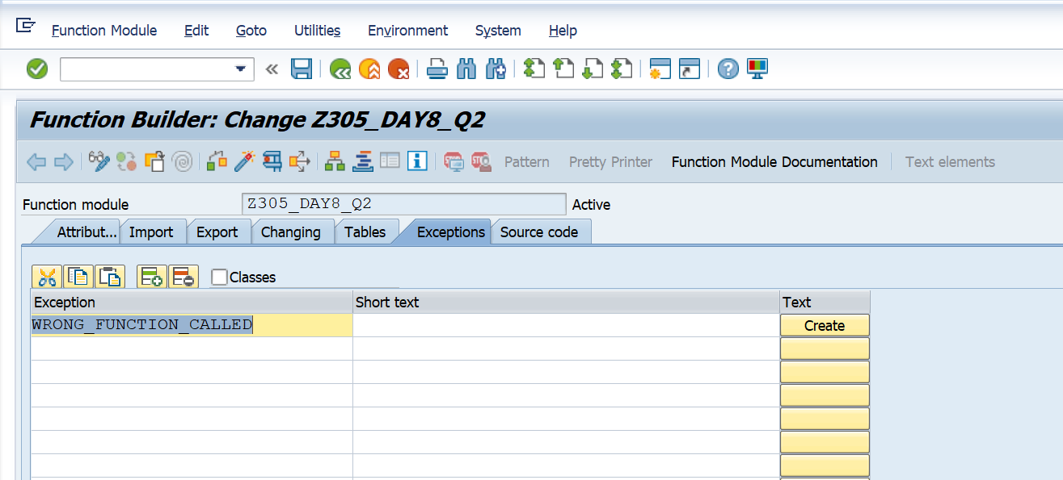

WE42 :- CREATE INBOUND PROCESS

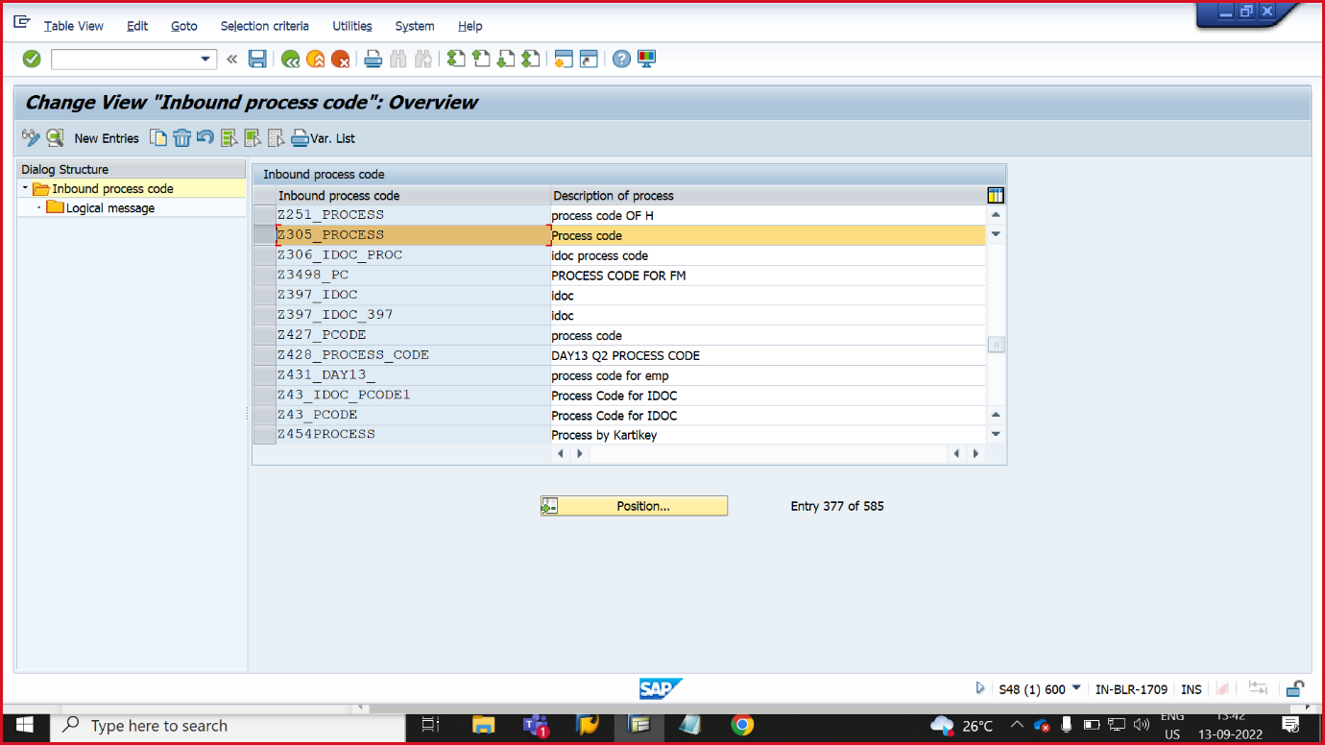

BD54 :- LOG SYSTEM

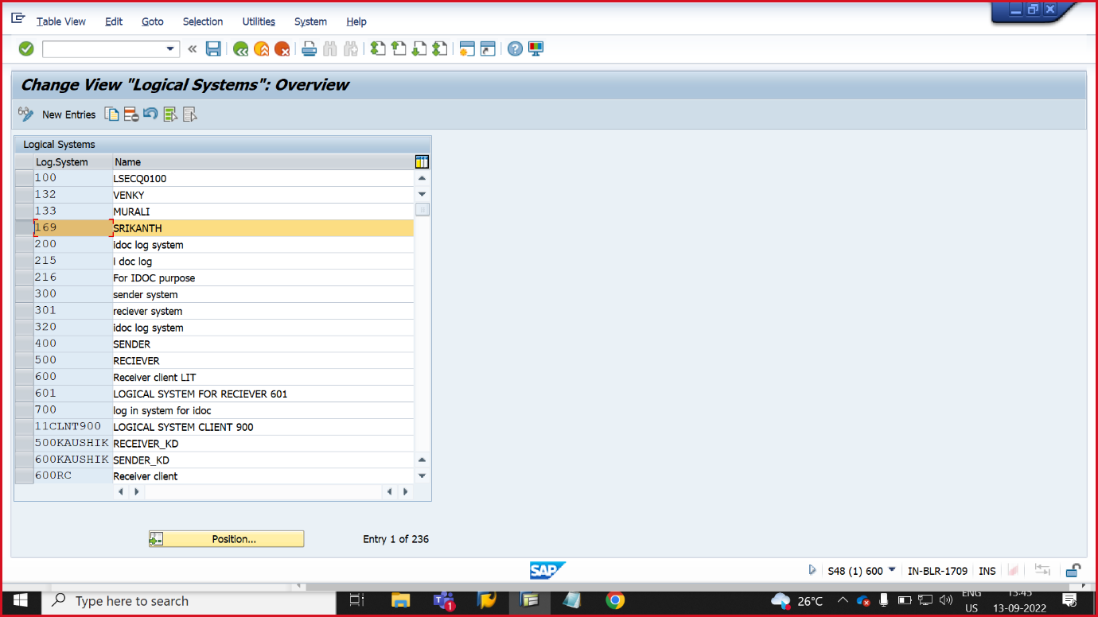

SM59:- RFC DESTINATION

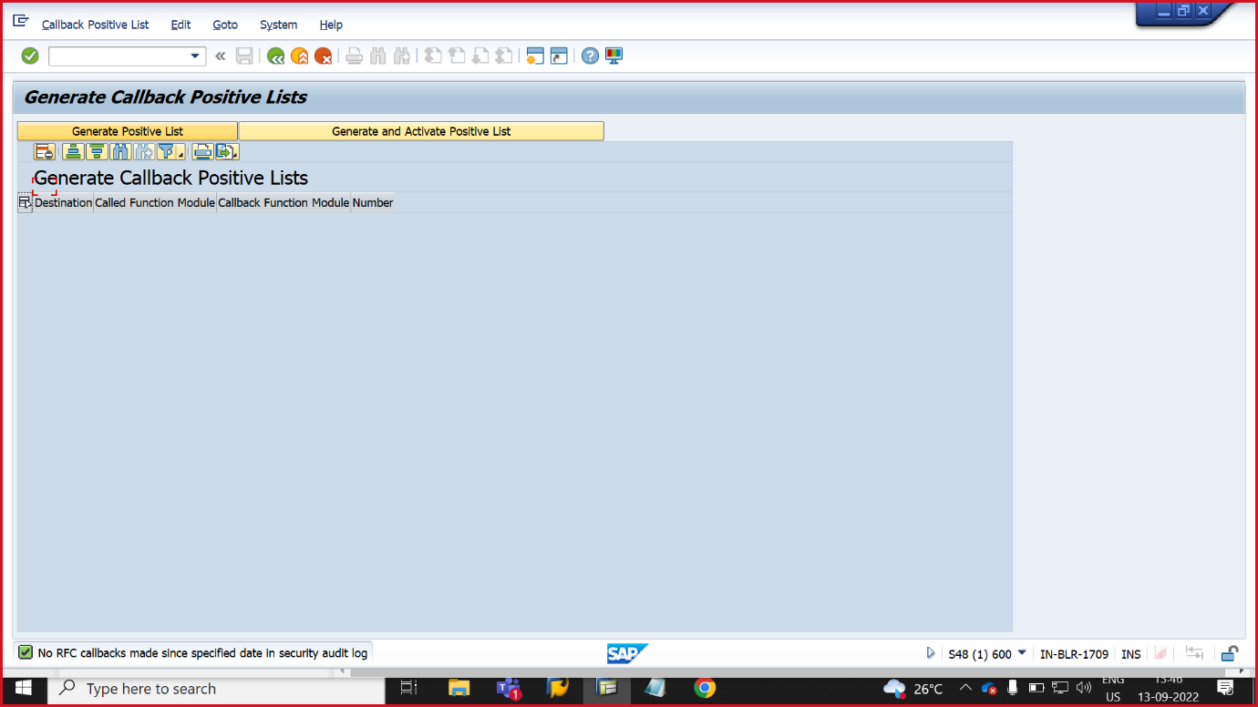

WE20 :- PARTNER PROFILE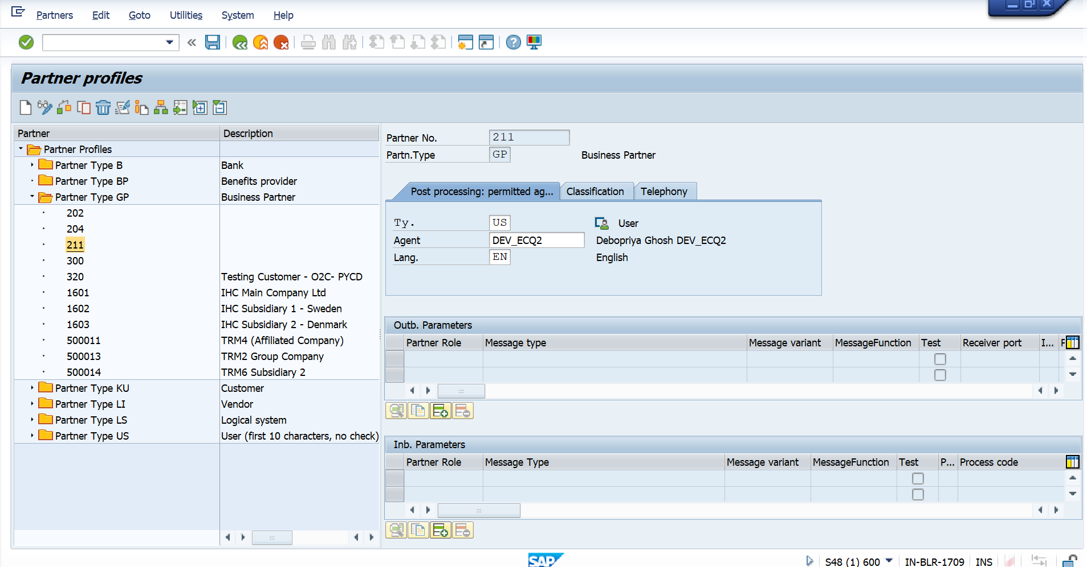WE19 :- TEST TOOL FOR IDOC